

**The Holiday Plane and Train Garden**

**Sponsorship Application**

Open: 1) November 30, 2024 to January 5, 2025

Wednesday, Friday, Saturday, Sunday: 11 am to 4 pm

Open Extra Days: 2) December 26, 27, 30, 31: 11 am to 4 pm

Check the website for cancellation due to unforeseen circumstance.

LOCATION OF DISPLAY – 2323 Eastern Boulevard in Middle River, Maryland

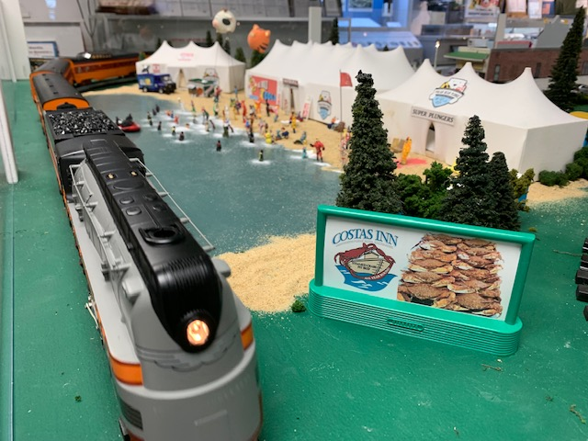Features:

* Washington, D.C. Capitol Hill
* Car Show at Ocean City, Maryland
* The Glenn L. Martin Company Plant No. 2

Advertise your business here!

* Richardson Farms
* Stemmers Run Train Station

And much more!

**-- - - - - - - - - - - - - - - - - - - - - - - - - - - - - - - - - - - - - - - - - - - - - - - - - - - - - - - - - - - - - - - - - - - - - - - - - - - - - - - - - - -**

**SPONSORSHIP APPLICATION - 2024 Holiday Plane and Train Garden**

Company/

Organization: _________________________________________________________________Date:_____________

Address: ______________________________________________________________________________________

City, State: __________________________________________________________________Zip:________________

Contact Name: _____________________________________________________Phone: _______________________

Email: _________________________________________________________________________________________

___Yes, I would like to make a donation (without a billboard) in the amount of $_____________________

___Yes, I would like to make a donation for a billboard in the amount of $100.00 $_____________________

**Attach your design or a business card for the billboard - 2 ¼” by 5”**

**Make check payable: GLMMAM.** Total amount enclosed: $_____________________

**Mailing address: GLMMAM, P.O. Box 5024, Middle River, MD 21220**