**The Glenn L. Martin**

**Maryland Aviation Museum, Inc.**

**Location: 701 Wilson Point Road at Martin State Airport, Hangar Five, Suite 531, Middle River, MD 21220**

**410-682-6122 \*** [**www.MdAirMuseum.org**](http://www.MdAirMuseum.org) **\* MartinMuseum@gmail.com**

August 28, 2024

White Marsh Law Firm, LLC

1513 Martin Blvd.

Middle River, MD 21220

Dear Business Manager and Friend of the Museum:

The Glenn L. Martin Maryland Aviation Museum is excited to announce that the Holiday Plane and Train Garden will once again be showcased at the Lockheed Martin E-building located at 2323 Eastern Boulevard in Middle River, Maryland. The exhibits and displays will open on Saturday, November 30 and close on Sunday, January 5, 2025. The operating hours are Wednesday, Friday, Saturday, and Sunday between the hours of 11 am and 4 pm. Plus, additional days on December 26, 27. 30 and 31. Admission is free and the attendance is expected to be larger than all the previous years. Indeed, it will be the place to see and be seen this holiday season. This is a premier event for the community which is quickly approaching.

The Museum is looking for sponsors for the Holiday Plane and Train Garden, which will viewed by thousands of visitors. For a contribution of $100 or more, your business or organization will be promoted with a 2 **¼’’ x 5”** billboard, placed in a prominent location within the train garden. Also, sponsors will be acknowledged in social media, at the exhibit site, and in upcoming issues of the newsletter of the museum.

To become a sponsor of The Holiday Plane and Train Garden, please complete the enclosed form and return in the envelope provided. Your support will ensure the continuance of this holiday tradition with fascinating improvements, and create memories for all.

Friends of the Museum, thank you for your help and support. Heritage, place, history, artifacts, and community combine to make magic at The Glenn L. Martin Maryland Aviation Museum. Even if you cannot donate at this time, please come out and experience the magic.

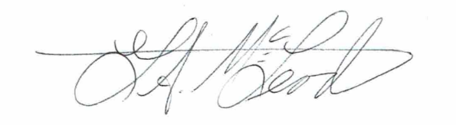I look forward to seeing you. With deep affection and warm regards, I am,

Gustavus McLeod

Executive Director

The Glenn L Martin Maryland Aviation Museum

The Glenn L. Martin Maryland Aviation Museum was incorporated in 1990 and is a 501(c)(3) nonprofit organization with a mission to celebrate aviation history in Marland by honoring our past and inspiring the future. Deductions are tax deductible – allowable to the full extent of the law.